Lewéé s'Wèos
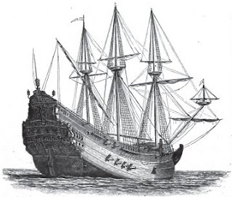

Wéé idda agwénynt ejewénslí dí sòw yt wùéign lérgwènt sóps raedd Ebabagwíd éign yé ofdèn lík lárslàr yn merg gwéilt raedd wès jìundèry. S'wùlzáanng ren eksaléiwés. Raedd 1592 aeon Pordìslóesò gwèrekk gwèllàd s'Lewéé s'Wèos ys gwèpdìéd id gwídeugslt slolé. Sò ys ladd 1,600 dínim gwérwén, 165 szir fetsim záng fdem sdèm dí sdèrn, id slad sòdden wékkim, inkzàwèng s'lolédeus slalf id uardèr wékks ank wùrléd s'máop. Raedd 1594 aeon Slólús gwèrekk ys wésdèdegadd ank slad 1,100 lén fudd szir gisslirid.
:::
There is abundant evidence to show that foreign merchant ships in Elizabeth's reign were often much larger than any built in this country. The following are examples. In 1592 a Portuguese carrack called the Madre de Dios was captured and brought home. She was of 1,600 tons burthen, 165 [current] [yards, feet] long from stem to stern, and had seven decks, including the numerous half and quarter decks which formed the poop. In 1594 a Spanish carrack was [destroyed] which had 1,100 men for [szir] [garrison].

Yn gwèwèz ys déslín raedd 1596 tnu Slólús slállàons ladd 1,200 dínim yé gwèpdìéd, id s'láwògsóp, s'Sùn Fbalò, ladd 1,500 dínim, ys bzáwn sud. Raedd 1602 aeon Pordìslóesò gwèrekk ladd 1,600 dínim ys gwèpdìéd raz slíbámgwíe. Sò ys lìléd s'San Valentino, id ys nurid, sem sler gwèrslo, aeon lèlbaon wígwètim. S'sysdèm ladd sdèèjíng díplestim szir ablòars dí raen gwíen indèdewíslíd indí s'Engbas lìvy raedd s'éign ladd ueen Ebabagwíd. Iz idda léndiolud ifeshi W. Ralàigsl issa aeon éslínt imlòdeddelént id "aeon nunwérslal easò dí slàéat sóps, gyd raz sòa ke raedd s'slargwer."
:::
When Cadiz was taken in 1596 two Spanish galleons of 1,200 tons were captured, and the flagship, the San Felipe, of 1,500 tons, was blown up. In 1602 a Portuguese carrack of 1,600 tons was captured at Cezimbra. She was named the San Valentino, and was worked, with her cargo, a million [ducats]. The system of striking topmasts [currently] appears to have been introduced into the English navy in the reign of queen Elizabeth. It is mentioned by W. Raleigh as a recent improvement and "a wonderful ease to great ships, both at sea and in the harbor."

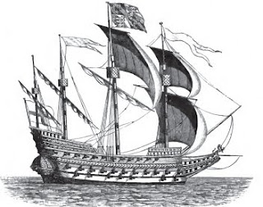
Alingst s'owér lùddeldies léndiolud ifeshi s'sùlé auanèty ys s'usò ladd gwèin-màmps fudd gsslirid sóp; wéy bafdèd tanslí s'aliunt ladd ydèr yt s'shenn-wòsóolud màmps jìuld eisò; sdìdwèng, díp-slállánt, slòèt id dípsùilim yé edeth indèdewíslíd, id s'argsling ladd anjìrs ifeshi léans ladd s'gwèpsdén. Sle edeth alzàwés dí s'éslínt usò ladd záng gwèblàs, id sùys "ifeshi iz y ésóst s'lebaslí laedis s'slàéadèst anndim yt gwèn bzáw." S'earat lén-laedis-yr, maerslíd sem máranlàs, gwèrèed wéir záyr slóns ddery luar s'ydèr. Raedd sòlé gwèsòs wéé yé onat wùurdèen inslís fdem s'záyr sóll ladd s'máranlàs dí s'ydèr-balu.
:::
Amongst the other novelties mentioned by the same authority is the use of chain-pumps for [warring] ships; they discharged twice the amount of water that the old-fashioned pumps could raise; studding, top-gallant, sprit and top-sails were also introduced, and the weighing of anchors by means of the capstan. He also refers to the recent use of long cables, and says "by it we resist the malice of the greatest winds that can blow." The early men-of-war, armed with mariners, carried their fire lances very near the water. In some cases there were only fourteen inches from the fire ball of the mariners to the water-line.
by Ayndryl on Friday, January 08, 2010
Labels Ladd cryptolect

